2022
JULY – No monthly meeting
12 Girls Night Out
22 Blood Drive

AUGUST - No monthly meeting
2 National Night Out (1st Tuesday)
SEPTEMBER
5 Silent Auction Ends 9:00 pm
12 Olney Open Charity Golf Tournament
13 Dinner and Board Meetings
23 Blood Drive – Sandy Spring Friends 11-4
OCTOBER
24 Dinner Meeting – Joint with Sandy Spring Lions
District Governor will be in attendance
(6:30 pm Ballroom at Sandy Spring Fire House)
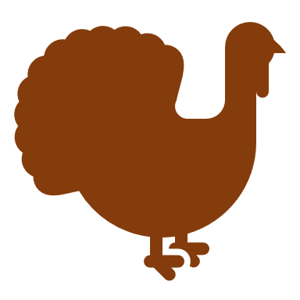
NOVEMBER
8 Dinner & Board Meetings
11 Veterans Day Recognition
18 Toys for Kids: Place Boxes at Locations
Toys for Kids: Toy Collection Begins
27 Holiday Decorating Corner 108 & Georgia Ave
DECEMBER
2 Blood Drive – Sandy Spring Friends 11-4
10 Toy Distribution Ross Boddy
Loading Toys
a. Need driver for truck
b. Need 3 volunteers to load truck
Toy Distribution
a. Need driver for truck from McCready’s to
Ross Boddy Rec Center.
b. Need volunteers: Toy distribution at
Ross Boddy Rec Center
c. Need driver to take toys to McCready’s &
return truck to Rollings
13 Holiday Dinner

2023

JANUARY
10 Dinner & Board Meeting
Nomination Committee Formed
28 Melvin Jones Fellow Luncheon

FEBRUARY
7 Dinner & Board Meeting (1st Tuesday)

MARCH
5 Second 22C Advisory Meeting – Pres, VP, Treas,
Membership, Leisure World
14 Dinner & Board Meeting
Nominations Slate Presented
Obtain Convention Delegates

Melvin Jones Nominating Meeting
Semi Annual Dues – Inter, Multiple 22C, and Dist 22C
APRIL
- 22C Night
10 Community Night - Good Counsel HS
11 Vote on Nominations Slate
Obtain Convention Delegates
20-23 Lions 22C Convention, Ocean City, MD
30 Olney Days Parade

Secretaries Report New Officers
Secretaries Report on 22C 5 Star Award
MAY
9 Dinner & Board Meeting
Charter Night Planning
20 Theater Night Social – “The World Goes Round”
JUNE
TBD Strawberry Festival
7-11 Lions International Convention Montreal
13 Charter/Awards Night
Installation of New Officers

